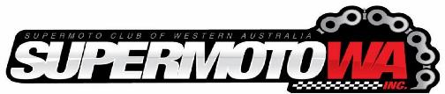

Club Championship Round 2

Presented by

Featuring Supermoto Open
Supermoto Clubman
Minimotard Senior
Minimotard Clubman
Postie Bikes
J1 (Recreation class 7-12)

Permit: SM/24/C/10519

Wanneroo International Kartway Sunday 21st April 2024

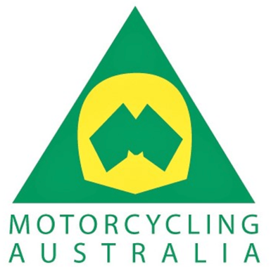
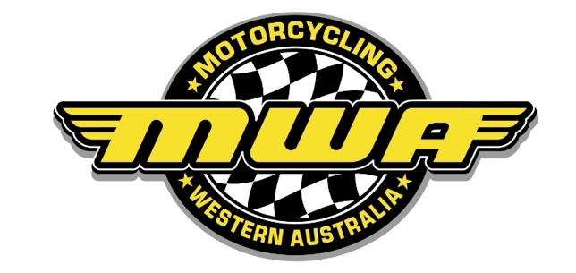
WARNING TO THE PUBLIC
Motorcycle racing is dangerous, and spectators attending this track do so entirely at their own risk. It is a condition of admission that all persons having a connection with the promotion, and/or organisation, and/or conduct of the meeting, including the owners of the land and the riders and owners of vehicles and passengers of vehicles, are absolved from all liability arising out of the accidents causing damage or personal injury to spectators or ticket holders, except where due care and skill has not been exercised.

NOTICE
No animals allowed.
Guide dogs and assistant animals excepted.
By order, Motorcycling Australia Ltd.

Officials:

Club Steward | Christopher Mercer
Race Secretary | Kathleen McQueen
Scrutineer | Robert Fry

2024 Club Championship Title Sponsor

Dowsing Group is a diversified civil subcontractor that delivers specialised services across hardscapes, profiling, slipform, diamond grinding and grooving, and civil services that work hand-in-hand to provide a range of complementary solutions.

With expertise across multiple service lines, and experience in wide-ranging projects with the capability to deliver large-scale and complex scopes.

Their teams have experience working on projects of all sizes from major road infrastructure projects through to streetscape enhancements in local communities.

Regardless of the size or nature of the project, you can count on Dowsing to bring a solution-focused team ready to deliver a high-quality outcome. Dowsing pride themselves on being highly responsive, easy to deal with and following through on what they say.

Open Throttle - Club Sponsor 2024
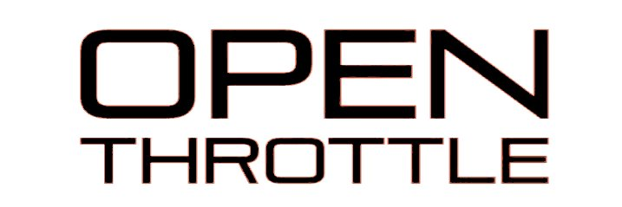
SupermotoWA are excited to partner with Open Throttle, a WA based custom apparel company, to handle all of our merchandise design, printing and stock management for 2024.

Together we will be able to offer our members exclusive deals and gear including hoodies, shirts, custom jerseys, and more, all at special member-only prices.

The partnership also opens doors for exciting co-branded initiatives and promotions throughout the season. Get excited for 2024!
Supermoto Open

Proudly Sponsored by Perth Husqvarna – GasGas
Phone: (08) 9430 4192
33 Rockingham rd Hamilton Hill

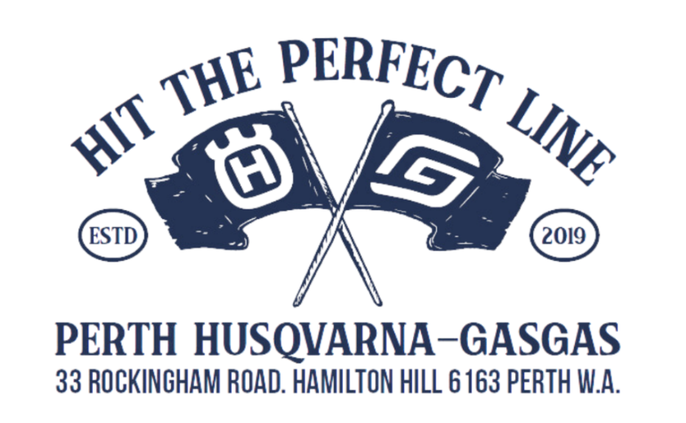
10 | David | Robertson | Rick Gill Motorcycles, Diablo Moto Custom Paint
456 | Harley | Radovan | Focused on Finance
111 | Ian | Kibble | Kibbs Motorsport
379 | Joe | Bowers
11 | Murray | Mackellar
64 | Paul | Kleinberg
41 | Stephane | Blanc
688 | John | Grupillo | JE Civil

Perth Husqvana and GasGas are WA's premier Husky and GasGas dealer, having recently supplied nine 2023 Husqvana FS450 Factory supermotos for both new and existing SupermotoWA members!

SupermotoWA are excited to have their support in 2024 to continue to grow the sport and our community. Want to get into Supermoto? Look no further than Perth Husqvarna and GasGas!

Supermoto Clubman

Proudly Sponsored by Aussie Moto Engineering
Phone: 0427947137
Muchea, WA

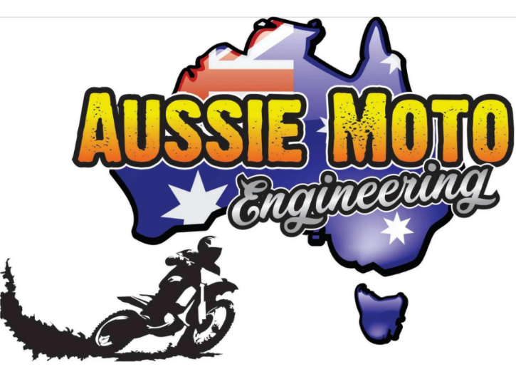

199 | Andrea | Bravo
818 | Anthony | Rampin | Bunbury Dyno GoMoto Store
71 | Callan | Sayers | Callan Sayers Motorsport
100 | David | Mason
20 | Jack | Harney
14 | Kobi | Treversh | TeamTea Racing, John Innes Photography, HSM Photography
101 | Lee | Chapman
22 | Max | Perrin
222 | Reece | Kibble
281 | Ian | Lawford
94 | Terence | Segetin
Every bike mechanic says they are the best in Perth, but only one can, and that is without a doubt Aussie Moto Engineering. Servicing everything on two or four wheels from farm quads to high end race bikes, Aussie Moto can do it all with a well-equipped workshop, expert knowledge and experience, the team will stop at nothing to ensure they solve their customers problems and have their bike up and running in no time! You’ll notice Aussie Moto built and maintained race bikes for international riders like Australian ex-MotoGP and Moto3 riders, international talents and the championship winners across Supermoto, Minimotard, WA Superbike and various motorcross Championships.

Minimotard Open

Proudly Sponsored by Auto Pro Canningvale

222 | Adam | Baxter | Limitless Web Design
848 | Geoffrey | Weir | Autopro Canning Vale
23 | Graham | Pozzi | William Wallace
32 | Harrison | Hirst | Source Machinery / BM BIKES / FIVE STAR YAMAHA
12 | Kim | Scarlett | The bank of Kim
583 | Matthew | Palmer | Autopro Canning Vale
22 | Mohamed Faisal | Mohamed Ramlan
6 | Timothy | Rose | Aussie Moto Engineering, RS36, Victoria Hotel Toodyay, Toodyay Bakery, Toodyay Hardware & Farm, Shire of Toodyay

Established in 1982, Autopro is Australia’s oldest and largest independent automotive aftermarket parts and accessories retailer, that began as a marketing group to support independent automotive aftermarket retailers namely to consolidate their buying power.
The first retail catalogue was produced in 1984 and today Autopro distributes millions of catalogues per year to all corners of mainland Australia.
Autopro stores are mainly locally owned and operated and form a major part of the local community. As local businesses, Autopro stores specialise in their local communities’ unique needs by adding specialised ranges to their product offers.
Autopro dealers are very knowledgeable about all things auto and can provide you with the right information and advice to keep you out on the road.

Minimotard Clubman

Proudly Sponsored by Equity Settlements
Phone: (08) 9200 6148
P.O Box 5376, Canningvale South

13 | Dale | Paddon | YCF Australia
456 | Harley | Radovan | Focused on Finance
38 | Ryder | Clarke
94 | Terence | Segetin

Equity Settlements are a highly experienced team of agents for property settlements in Canning Vale. Your trusted partner in both Residential and Commercial settlements, title searches, and multilingual communication services.

Equity Settlements are dedicated to simplifying property settlements and ensuring a smooth and stress-free experience for every client. Whether you're a buyer, seller, or investor, contact them today!

Posties

Proudly Sponsored by Ace Motorcycles and Scooters
Phone: (08) 9300 1719
5/257 Balcatta rd Balcatta
222 | Adam | Baxter | Limitless Web Design
52 | Andrew | Chalkley
788 | Marcus | Haddon | MRN Racing,Motorcycle Tyres and suppliers 968,Kerb Doctor
111 | Matthew | Blythe | SmartRider Motorcycle
11 | Murray | Mackellar

Ace Motorcycles and Scooters are Perth's largest dealership with the biggest range of scooters and CFMoto motorcycles.
This partnership represents a great opportunity to promote supermoto to those in the market for their first bike, or to those who have bought the racing models already, and we can show them the cheap and adrenaline filled world of supermoto and minimotards!

We will look to collaborate with Ace to get some of their besoke Italjet Racing Scooters out on a trackday or two!

Minimotard Juniors

Proudly Sponsored by Motorcycle Bazzar
Phone: 0406 947 004
Email: motorcyclebazaar@gmail.com
Website: www.motorcyclebazaar.com.au/

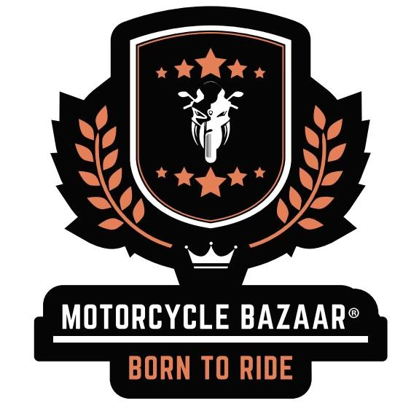

SupermotoWA is excited to welcome back Motorcycle Bazaar as a class sponsor in 2024! Motorcycle Bazaar provide top-quality custom leathers called Motorce by Motorcycle Bazaar. Their suits prioritise safety without compromising on style, offering custom sizing and design options. Their skilled artisans ensure a perfect fit, while premium materials provide unbeatable protection. Ride confidently in gear tailored exclusively for you!

We want to grow our junior classes in 2024, so partnering with Motorcycle Bazaar is the perfect match. We understand one of the biggest hurdles to get kids into the sport of supermoto is leathers. They grow so quick!
Motorcycle Bazaar will be custom making some suits for our selection of junior hire suits! Here is to an epic 2024!
J1 Juniors
7yr – 12yr Recreation class

Proudly Sponsored by JE Civil
Phone: 0417922144

 | Rian | Paddon | YCF Australia
 | Leo | Grupillo | JE Civil
 | Hunter | Radovan | Focused on Finance
 | Casey | Bowers
 | Joe Jr | Bowers

JE Civil, is no stranger to SupermotoWA! They are a leading civil engineering and earthworks company in Western Australia and brings more than just financial backing to the J1 Junior class.

Their expertise in building strong foundations resonates with Supermoto WA's mission to nurture future champions.

Speaking of building a solid foundation! These guys aren't just passionate about the sport, they're responsible for helping construct many of WA's major infrastructure projects, even including the Bunbury dirt section. Talk about putting your skills to the test! ️

With their support, the J1 Junior category promises to be a breeding ground for talented young riders, laying the groundwork for future success in the sport.

Wanneroo Track Map

The long track configuration is 1025 metres for Mini-Motard and
1230 metres for all other classes including a 290-metre dirt section. (23.5%).
Racing on all configurations will be in an anti-clockwise direction

